Entrepreneurship Sem 2 Docs

Week 4 allocation:
- Product and development:
  - Backend: jin and oli
  - ui/ux: stefy and oli
- Legal ethics sustainability: jay
- Market and launch activity: isaac
- User testing and stakeholder engagement: vlad

Also think about how we’re going to present the data, presentation, poster, business pitch, etc…

Could do something like shark tank

Week 5 allocation:
- Start designing the presentation and stakeholder engagement (need to think about questions and prepare ethical forms): Vlad

Week 6:
- Oli: UI UX and expo
- Jay: finish ui ux, look into sections 2,3,4 in improvements to do
- stefy: revenue, costs, finance, etc
- Jin: db integration and basic security measures
- Isaac: Continue working on marketing (advertisement and landing page), user feedback for logos?
- Vlad: presentation and feedback if possible

Week 7:
- Stey: social media mockup page, finish financial section
- Jay: can write a script for the sections i researched (legal, ethics, sustainability etc.)
- Oli:
- Jin:
- Isaac: Poster and getting form submissions, write script for market launch
- Vlad: Please write engagement and user testing

https://github.com/oliveripkanam/entrepreneurship2

Week 8:
1. Oli: cut down on script and make it flow better
2 Jay: cut down on script, make it flow better
3. Stef: presentation
4. Isaac: presentation
5: Vlad: cut down on script, make it flow better
6: Jin: presentation

https://groupkpantry.netlify.app/

Marketing and Launch Activity
Link to overleaf: https://www.overleaf.com/7827328267sxdnwswzpgsn#b83dcf

Subsections: Testing route to market | Branding, messaging and positioning | Pricing, distribution

Routes to market

Need to make evidence of how customers should find and buy from our app: Landing page, mock ad campaign or social media page?

Branding, messaging and positioning

Need to create our brand image: Logo, brand identity, target audiences etc

Pricing, distribution and customer acquisition

How much do we charge and how would we get the product to our customers

Need:
- Landing Page (Continue working on this)
- Feedback from customers
[Host our app and get customers to review our app]
- Ad campaign? (need to get started)
Instead of inhouse marketing, we can reach out to influencers

[which ad campaigns are our competitors running]
- Logo (the green one)
[note we need to test a few others and get feedback]
- Price? (Stef)
[stated in our previous coursework that it would be free but with a freemium model £1.99, maybe calculate how much we would need in costs and how many onboarders we would need to break even]

To make a landing page, the best option would be to vibe code it out and host it. A good idea could be to use github pages as it is free and hosted within our repo that people could view.

We need to track and have data on our site visits.

Landing Page

https://isaacau11.github.io/pantry-landing-page/

NOTES:
- Currently not completely accurate, completely vibecoded and hosted on github pages.

Possible logos?

Figma link: https://www.figma.com/proto/PUFAa3FtE0jFwsCn5N6s8g/Pantry?node-id=0-1&t=PzuW9wnRK8t7SvSW-1




Marketing

Instagram - canva, unfold, edits (app) :
Waitlist (Pre-launch interest)

When users add their emails to the waitlist on the Landing page, they are added to a list that collates all emails allowing us to know just how many people are interested.

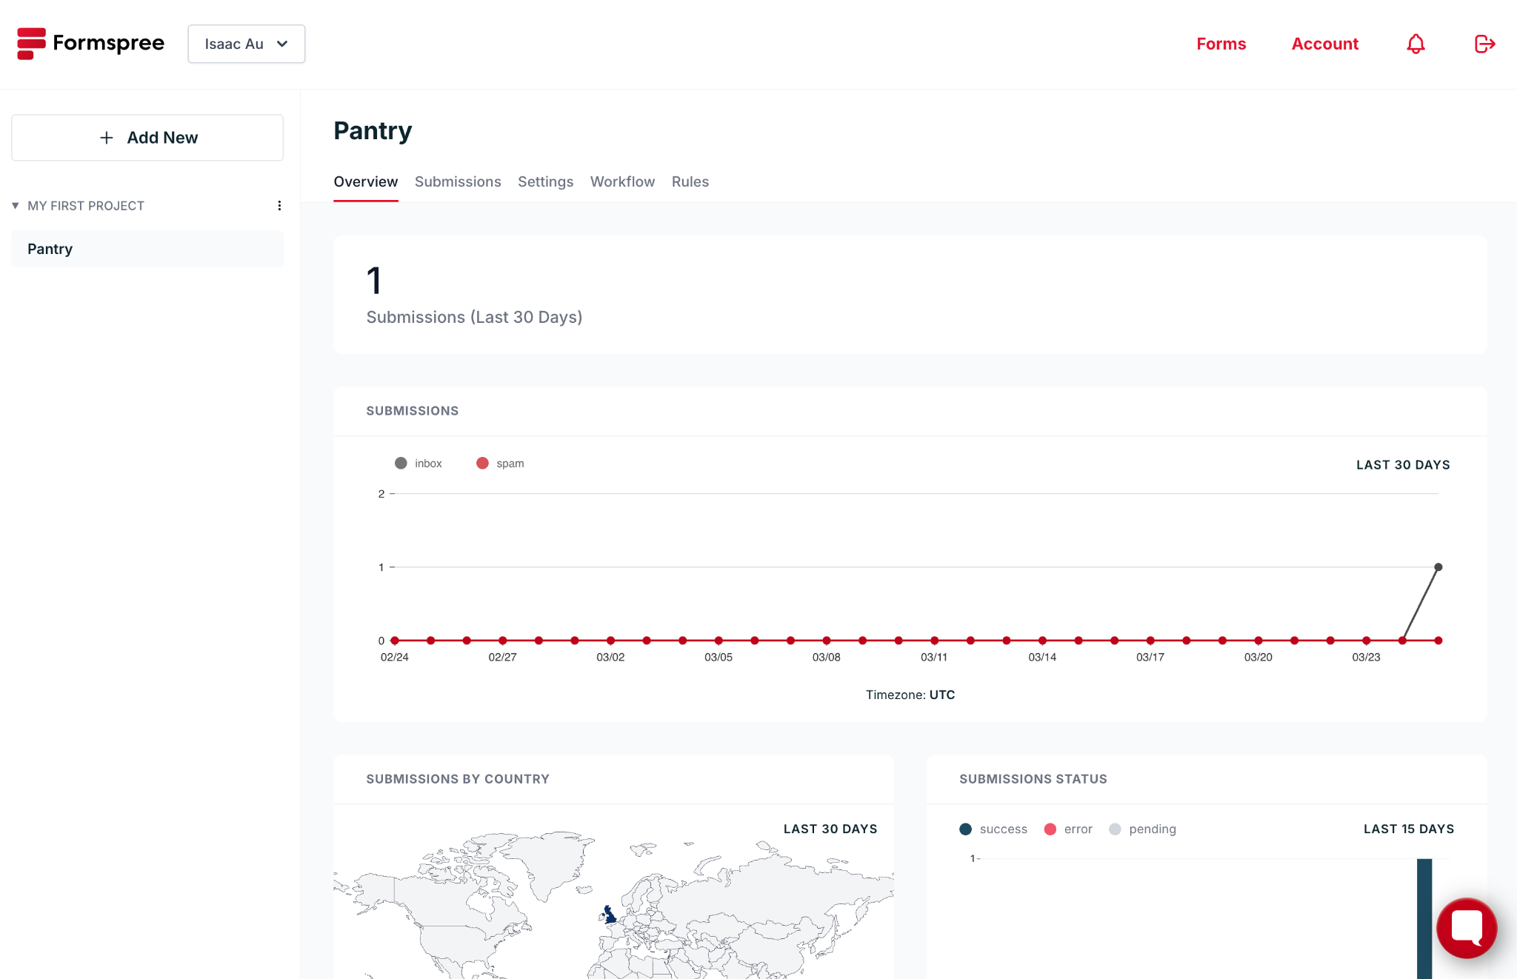

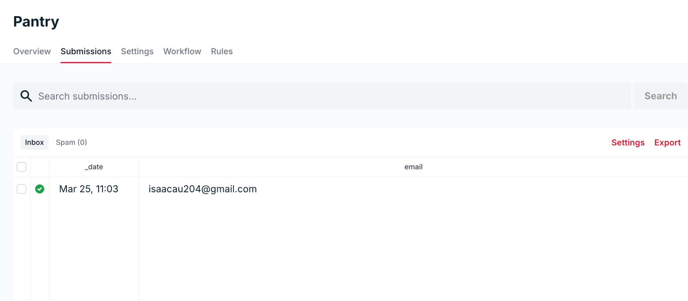

We now have a database of emails that sign up their interest, allowing us to breakdown where interest is from mainly and to see the impact of our marketing/ outreach campaigns.

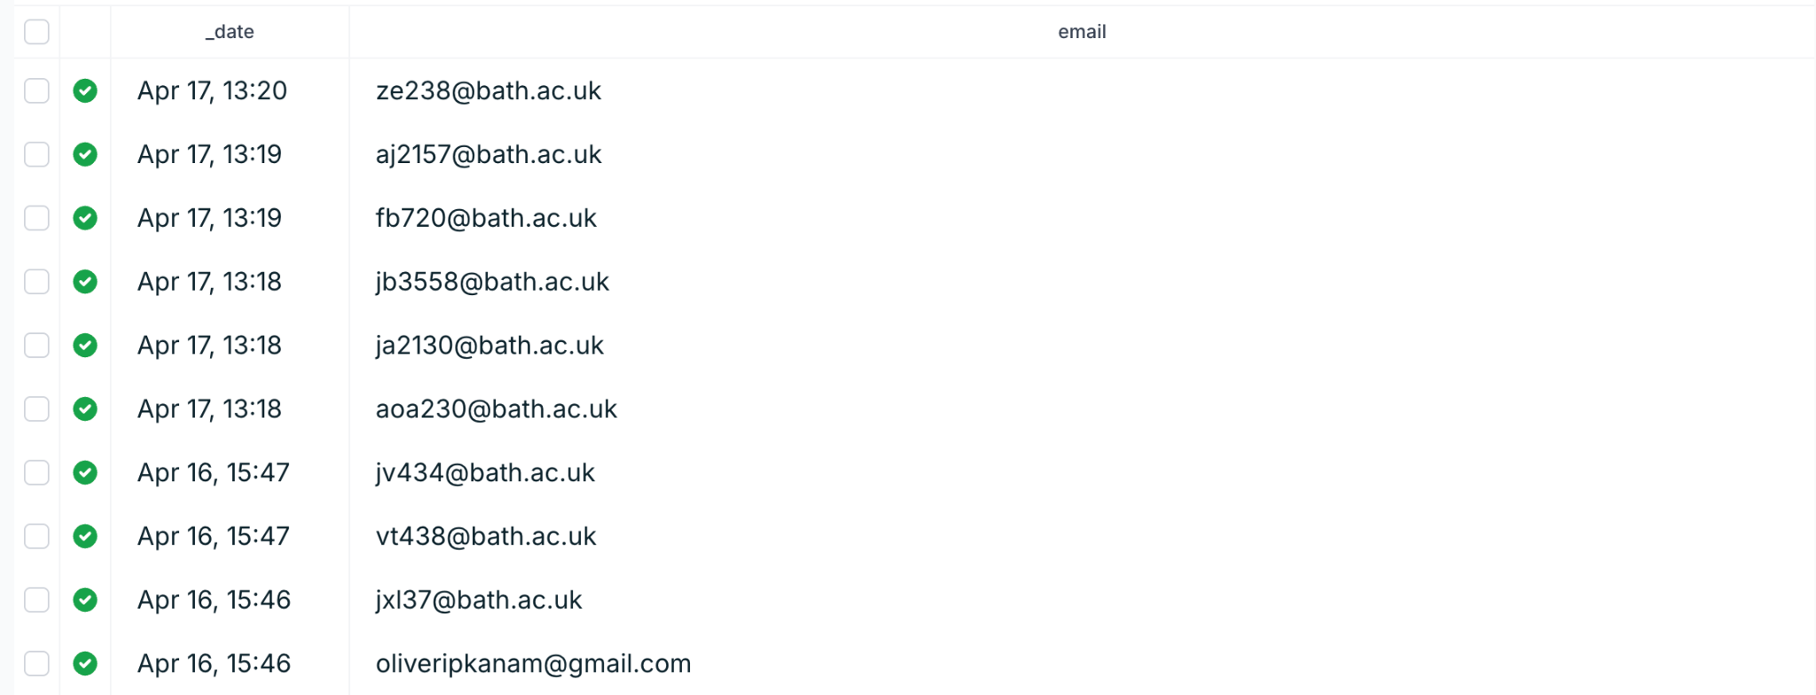

Webscraping services:
- https://www.unwrangle.com/
- https://rapidapi.com/localpearuk/api/uk-supermarkets-product-pricing
- https://actowizsolutions.com/datasets/details/web-scraping-tesco-grocery-prices

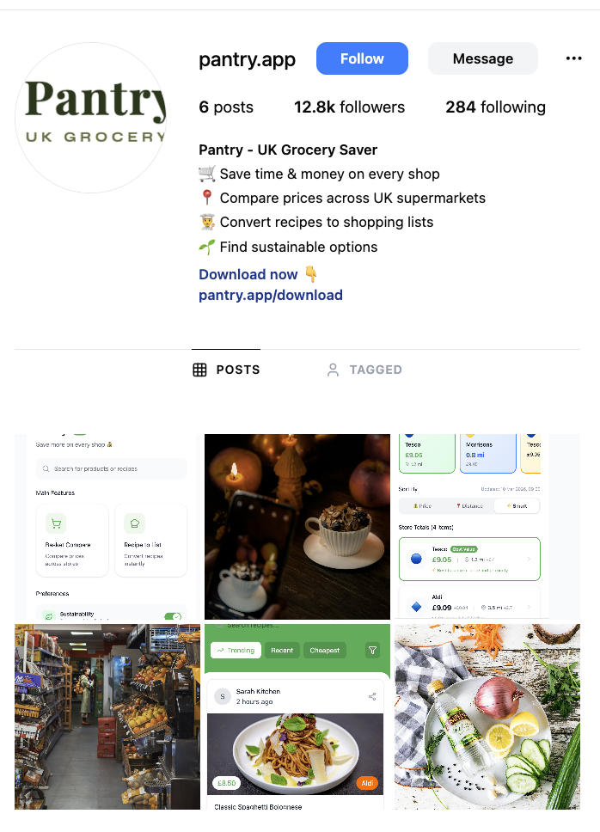

Legal, Ethics, Sustainability
Legal and Regulatory Issues:

- Data Protectiona and GDPR: As the app stores user preferences and dietary requirements, it must comply with UK GDPR and data protection laws. All user data must be processed with explicit consent and stored using industry-standard encryption. A transparency privacy policy detailing data collection and retention is needed.
- Intellectual Property (IP): The IP includes proprietary algorithms for Recipe-to-Basket parsing and the Supermaket-Comparison engine. A brand trademark for the name and logo should be registered to protect brand identity.
- Data Acquisition Compliance: To avoid legal disputes regarding unauthorised website scraping, pricing data must be sourced via official supermarket APIs or compliant third-party aggregation methods.
- DMCCA 2024: The app must comply with the Digital Markets, Competition, and Consumers Act (DMCCA) 2024 and updated Price Marking Order (PMO) rules effective April 6, 2026. This requires providing material pricing information in invitations to purchase and ensures standardised unity pricing for easier consumer comparison. (https://www.gov.uk/government/publications/price-marking-order-2004-government-guidance/price-marking-order-2004-government-guidance)
- App Store Interoperability: New CMA commitments from Apple and Google (taking effect April 1, 2026) provide UK developers fairer access to mobile operating systems. This could allow the app to request deeper interoperability with native device features, such as digital wallets or specialilsed app tools. (https://www.gov.uk/government/news/cma-secures-commitments-from-apple-and-google-to-improve-fairness-in-app-store-processes-and-enhance-ios-interoperability)
- Misleading Pricing Penalities: The CMA now has enhanced enforcement powers under the DMCCA to fine businesses up to 10% of global turnover for egregious breaches of price transparency, such as drip pricing or misleading loyalty discounts.

Ethical Implication:

- Price Transparency and Consumer Trust: The app addresses the lack of trust in loyalty schemes by providing the pricing toggle. This allows users to see if member-only prices offer genuine savings or if standard prices have been artificially inflated.
- Supporting Vulnerable Customers: By remaining a zero-cost consumer service, the app ensures that this tool for saving money is accessible to those who need it most.
- Health and Safety: The app provides safety through dietary filters.
- AI Explainability in Recipe Parsing: When using AI for Recipe-to-Basket conversion, there is an ethical duty to ensure the algorithm is transparent. users should be able to see why a specific product was mapped to an ingredient, particularlly for diet-specific consumers where errors have health or religious consequences.
- Addressing the "Food Desert" Disparity: Ethically, the app can serve as a social sustainability tool by identifying "food deserts" where local shops might be significantly more expensive than the national average, helping low-income families have limities access to affordable food. (https://www.ncbi.nlm.nih.gov/books/NBK208016/)
- Data Minimisation and Trust: Since user confidence in online food services is tied to familiarity and trust, the app should adopt a Privacy by Design approach. This involves collecting only the data necessary for Basket Comparison and offering a guest mode for those who want to avoid tracking of dietary habits.

Environmental and Sustainability Impacts:

- Food Waste Reduction: The Recipe-to-List features helps users purchase exact quantities of ingredients, helping reduce household food waste.
- Sustainable Choice Integration: While initial user feedback suggested sustainability ratings were a low priority, the app could include eco-friendly product indicators to encourage environmentally conscious shopping.
- Operational Footprint: By adopting a remote development model and utilising cloud infrastructure, it eliminates the need for a physical commerical office, reducing overall carbon footprint etc.
- Near Expiry: Could include a feature to show cheaper items that are near expiry, potentially reducing household food waste.
- Inventory Awareness: Could implement an inventory manager cuold prevent over purchasing, again reduing food waste. The idea is that the app reminds the user what they already have.
- CO2e Avoidance Tracking: Similar to Too Good To Go, the app could quantiy the environmental impacts of its Recipe-To-List feature by showing users the estimated CO2e avoided by purchasing exact quantities and reducing surplus waste.

Informed Operational Decisions:

- In-store Focus: Choosing to focus on in-store shopping rather than delivery caters to the majority of the market that shops physically, helping useres avoid delivery fees and minimum spend thresholds.
- Resilience Strategy: To ensure service continuity, the app is designed to fallback to open-source data if official or third-party APIs change their access terms.
- Affiliate Partnership Model: Positioning supermarkets as revenue parterns via affiliate channels creates a sustainable B2B revenue stream that keeps the app free for the end-user.
- Offline Accessibility: PWA ensures basket remains functional in supermarkets with poor signal.
- Community co-creation model: Having a social community hub allows the app to grow through network effects.

Stakeholder Engagement
User Testing and Stakeholder Engagement

Overview:
Interface & Layout

Too much text on screens making the interface dense and overwhelming on mobile.
Status: ✅ Addressed (layouts simplified and UI redesign initiated)

Some pages looked like a website rather than a mobile application.
Status: ✅ Addressed (UI components redesigned for better mobile usability)

Basket view should include more visual elements (icons, images, simplified layout).
Status: ⚙️ Partially addressed (introduction of clearer icons and improved visual cues)

Home page should include more visual representation and simplified layout.
Status: ⚙️ Partially addressed (UI redesign and layout simplification)

Home page contains too many buttons causing clutter.
Status: ⚠️ Not explicitly implemented yet

Clarity of Information

Numerical metrics displayed under basket products were confusing.
Status: ⚙️ Partially addressed (clearer labelling and visual cues planned)

Navigation & Usability

Some actions required too many screens or button interactions.
Status: ⚙️ Partially addressed (navigation flow improvements)

Difficulty comparing store distances and prices simultaneously.
Status: ✅ Implemented

Onboarding / Learnability

Need for an in-app tutorial/onboarding explaining system features and logic.
Status: ✅ Implemented

Feature Relevance

Price history graph considered unnecessary for grocery shopping.
Status: ✅ Implemented (feature removed)

Sustainability rating not useful for many users.
Status: : ✅ Implemented

Community recipe link on homepage adds clutter and should be removed or deprioritised.
Status: ✅ Implemented

Feature Requests

Map view showing nearby supermarkets.
Status: ❌ Not implemented yet

Price-per-serving estimates for recipes.
Status: ❌ Not implemented yet

Price sorting tools.
Status: ❌ Not implemented yet

Product quality indicators.
Status: ❌ Not implemented yet

Product reviews.
Status: ❌ Not implemented yet

Data Transparency

Visible “last updated” timestamp for price data.
Status: ✅ Implemented

Branding & Social

Stronger application branding.
Status: ✅ Mostly Implemented

Improved profile page
Status: ✅ Implemented

Business Model

Users were curious about how the app generates revenue.
Status: ✅ Implemented

Implemented | Partially Implemented | Not Implemented Yet
Removal of the price history graph, which users considered unnecessary and not meaningful for grocery shopping | Addition of more visual elements (icons, imagery, simplified layouts) on pages such as the home page and basket view | In-app tutorial / onboarding flow explaining how the system works
Reduction of text density through layout simplification to make screens less overwhelming | Clearer labelling and visual cues to help users understand numerical metrics under basket products
Redesign of key UI components to better match mobile application design rather than website-like layouts | Improved navigation flow to reduce the number of screens or interactions required for tasks | Reduction of excessive buttons on the home page to decrease clutter
In-app tutorial/onboarding explaining system features and logic
Removal or deprioritisation of the community recipe link on the homepage
Reconsideration or removal of the sustainability rating feature
Improved ability to compare store prices and distances simultaneously  Additional Comparison tools: price sorting  Addition of price-per-serving estimates for recipes  Addition of a map view for nearby supermarkets |  | Introduction of additional comparison tools: quality indicators, product reviews)
 |  | Addition of a “last updated” timestamp for price data
 |  | Improved application branding
 |  | Refinement of social-sharing functionality

Created all files needed for stakeholder engagement.

Potential questions:

1. Is the interface clear and easy to use on a mobile screen?
2. Do the icons and visual elements help you to understand the interface more quickly?
3. Did any part of the interface feel cluttered or difficult to navigate?
4. When viewing product information, do you clearly understand what the numbers and metrics represent?
5. Is there any information missing that would help you to compare products more easily?
6. How easy was it to create a shopping basket and compare prices between supermarkets?
7. Did the price comparison seem reliable and easy to understand?
8. Would this comparison realistically change where you shop?
9. Was it intuitive to convert a recipe into a shopping basket?
10. Would the recipe-to-basket feature help you to plan meals or shop more effectively?
11. Is the loyalty pricing comparison easy to understand and useful for comparing stores?
12. Does the current version focus on the most useful features for grocery planning?
13. What additional information or features would help you to make better shopping decisions?
14. Realistically, would you use this app before doing your grocery shopping?
15. Which feature in the current version of the app is the most useful?
16. What improvement would you suggest for the next version?

Some ideas for stakeholder engagement:
It could be a good idea to record a few short reactions from users testing the updated version of the app. Since some of them took part in the initial stakeholder session, it would be interesting to demonstrate how their feedback has helped to improve the system over time.
For the final video, we could include very short clips of users saying a quick sentence about their experience with the new version. These don't need to be long — just simple reactions such as:
'I like how easy it was to build a trolley.'
'The price comparison is much clearer now.'

Is the interface clear and easy to use on a mobile screen?
Mostly yes, but some section names are confusing and could be clearer.
Do the icons and visual elements help you to understand the interface more quickly?
Yes, the icons and visuals are helpful.
Did any part of the interface feel cluttered or difficult to navigate?
The basket comparison and recipe-to-list features felt slightly confusing to navigate.
When viewing product information, do you clearly understand what the numbers and metrics represent?
Not entirely — labels such as “fresh”, “value”, and “premium” are unclear.
Is there any information missing that would help you to compare products more easily?
Information about product quality would improve comparisons.
How easy was it to create a shopping basket and compare prices between supermarkets?
No major issues were reported, but no strong feedback was provided.
Did the price comparison seem reliable and easy to understand?
Yes, it was generally easy to understand.
Would this comparison realistically change where you shop?
Probably not, as users often have existing preferences and habits about where and what they buy.
Was it intuitive to convert a recipe into a shopping basket?
No, this feature was not very intuitive.
Would the recipe-to-basket feature help you to plan meals or shop more effectively?
Potentially yes.
Is the loyalty pricing comparison easy to understand and useful for comparing stores?
No clear feedback was given.
Does the current version focus on the most useful features for grocery planning?
Yes, overall it focuses on useful features.
What additional information or features would help you to make better shopping decisions?
More emphasis on product quality would be helpful.
Realistically, would you use this app before doing your grocery shopping?
Probably yes, although users may rely on memory for regular purchases.
Which feature in the current version of the app is the most useful?
Price comparison.
What improvement would you suggest for the next version?
Improve the AI functionality, as it has strong potential but needs to work more reliably.

Logos feedback:

Logo 1 | Logo 2 | Logo 3
8 | 10 | 6

Overall, the first logo is considered catchy and attention-grabbing. However, users disliked the inaccurate mushroom graphic on the right side.
The second logo is viewed as the most elegant and luxurious. While the font is well-received, users did not like the flower element on the left side.
No specific feedback was provided for the third logo beyond its lower rating

Frontend

Backend
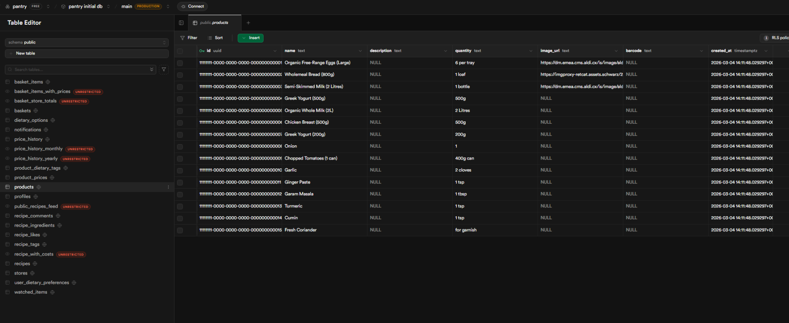
Mock db example on supabase

Improvements To Do

1. Financial Sustainability and Strategy
One of the primary reasons startups fail is running out of cash. While your current model relies on affiliate commissions and native advertising, you should address:
- Burn Rate and Runway: Calculate exactly how much it will cost to maintain your cloud infrastructure and data APIs monthly. How many months can you survive before needing to be profitable?.
- Unit Economics: Since grocery affiliate commissions are low (1–3%) , you must ensure your Customer Acquisition Cost (CAC) remains lower than the Lifetime Value (LTV) of a user.
- Funding Appropriate to Stage: For your Year 1 pilot in Bath, consider bootstrapping or small university grants rather than seeking Venture Capital too early.

2. Scaling Mindset and Market Access
Many UK startups fail to reach hyperscale because they think UK-first instead of World-first.
- Global Architecture: Even if starting in Bath, ensure your "Recipe-to-Basket" parsing logic is designed to handle international retailers from day one.
- Regulatory Compliance: Scaling into Europe requires navigating fragmented regulations like GDPR and the AI Act. Your current legal strategy covers UK GDPR, but you should plan for wider compliance.
- Avoid Early Exit: A common pitfall is selling to a larger company (like Google or Microsoft) before reaching full potential. Consider what it would take for Pantry to remain independent like Spotify.

3. Innovation and Intrapreneurship
As Pantry grows, you must consider how to maintain the "culture of speed" that US hyperscalers use to stay ahead.
- Continuous Iteration: "Move fast and break things". Use the feedback from your 11-student pilot to launch a Version 2 quickly, even if it feels "embarrassing" or imperfect.
- Intrapreneurship: If your startup grows into a large company, how will you encourage employees to act like entrepreneurs within the firm to keep innovating?.
- 10x Thinking: Instead of incremental improvements, ask: "What must be true to serve 1 million customers tomorrow?". This might mean moving away from manual data verification to fully automated AI agents.

4. Failure Resilience (F.A.I.L.)
Failure is an essential source of feedback.
- Fail Fast, Fail Cheap: If a feature like "Social Recipe Sharing" adds clutter without driving revenue, be prepared to pivot or remove it quickly to save resources.
- Strategic Risk: Don't avoid risks entirely; the biggest risk is not taking any. For example, challenging the restrictive terms of supermarket APIs might be necessary to provide the loyalty pricing transparency your users demand.
Pantry Improvements

Financial Sustainability and Strategy
The primary reason 90% of startups fail is running out of cash, with 38% specifically citing fundraising or liquidity exhaustion. To ensure Pantry avoids this traditional failure path, we have developed a strategy centered on Exponential Efficiency—using systems rather than heroic effort to manage growth.

  - Burn Rate and Runway (The Survival Metrics)
Finance is about survival, requiring a rigorous understanding of the Monthly Burn Rate (spending) and the Runway (time remaining).

Item | Monthly Cost | Strategic Justification
Data (PriceAPI) | £210.00 | Scalable variable cost; 50k requests/month.
Hosting (Netlify/AWS) | £45.00 | PWA Architecture to ensure offline access in Bath supermarkets.  Scale Architecture: Pay-as-you-grow backend that remains stable regardless of traffic
Marketing (CAC) | £150.00 | Influencer-led Viral Loop strategy to target SOM at <£2.00/user.
Legal/Compliance | £25.00 | Provision for GDPR security and DMCCA transparency compliance.
Total Burn Rate | £430.00 | Runway: 7 Months (based on £3k founder bootstrapping).

The Runway Calculation:
$Runway =\frac{Total Cash}{Monthly Burn}→\frac{£3,000}{£430} = 6.97 Months$

  - Unit Economics: CAC vs. LTV
In the grocery sector, where affiliate margins are a lean 1–3%, we must maintain a high LTV:CAC ratio to remain viable.
- Customer Acquisition Cost (CAC): We have rejected Paid Search (Industry Avg: £18.00) in favor of micro-influencer collaborations and organic loops to target a CAC < £2.00.
- Lifetime Value (LTV):
  - Affiliate Revenue: Projected at £1.20 per shop (2% of a £60 basket).
  - Native Advertising: Estimated £0.16 per user/month via Sponsored Product impressions.
  - Total Monthly Revenue: £4.96 (Assuming 4 shops/month).
- Breakeven Analysis: To cover the £430.00 monthly burn, we require 359 weekly shop conversions per month.
- LTV Projection: At an average user lifespan of 6 months, the LTV is £29.76, creating an LTV:CAC ratio of ~15:1, far exceeding the 3:1 industry benchmark.

The Breakeven Calculation
The number of transactions needed depends on which customer segment is shopping, as their Average Order Value (AOV) and resulting commissions differ.
Revenue Source | Avg. Revenue per Event | Transactions to Breakeven
Affiliate Commission (2%) | £1.20 (on £60 basket) | 359 shops / month
Native Advertising (CPM) | £0.16 (per user / month) | 2,688 active users / month
Freemium Sub (Year 2) | £1.99 (per sub / month) | 217 subscribers / month
Strategic Implications for the Bath Pilot:
- Targeting the SOM: Our target for the Bath pilot is 2,500 students. If we capture just 15% (375 students) and they perform one shop per month, the business becomes self-sustaining from affiliate revenue alone.
- Failing Forward Strategy: If the initial pilot shows low shop frequency (e.g., once every two weeks), we will treat this feedback as a gift. According to the Fail Fast framework, we would pivot our marketing to lean harder into the Recipe-to-List feature, which encourages larger bulk-buying baskets and increases the commission per click.

  - Funding Appropriate to Stage

Following the 6 Stages of a Startup framework, Pantry is currently in the Pre-Seed/Idea Stage.
- Bootstrapping (Current): We are using our own time and sweat equity as the first investment to retain 100% control.
- Non-Dilutive Funding: We are targeting University of Bath entrepreneurship grants and Innovate UK Smart Grants (up to £500k) to fund the pilot without giving away equity.
- SEIS Readiness: For future external engagement, we will structure for Seed Enterprise Investment Scheme (SEIS) eligibility, offering UK investors 50% income tax relief to subsidize their risk.
- Avoid Premature Scaling: We will focus on the Year 1 Bath Pilot to validate technical stability and build Scale Architecture before seeking Series A funding for national expansion. We don't need to spend £50,000 on massive servers today; instead, we build the architecture that could support them, but we only pay for what we need now (£45/month).
- Risk Mitigation (Licensing): While Trolley.co.uk incurs high annual costs for product image licensing, we are initially mitigating this risk by sourcing open-source images from Open Food Facts.
- Future Pivot: As we scale beyond our 7-month runway, we have identified Image Licensing as a core line item for our Series A funding round to ensure we maintain Technical Excellence without legal breach.

Scale Architecture
- Technical Scale Architecture
This involves choosing technologies that can expand horizontally as the user base grows.
  - Automation over Manual Labor: Instead of having a team member manually check supermarket prices, we use a scalable API like PriceAPI. This ensures that whether we have 100 or 100,000 users, the data remains accurate without extra human effort.
  - Cloud Infrastructure: Utilising services like AWS or Supabase (as noted in the hosting costs) allows the backend to automatically provision more power as traffic increases.
  - Progressive Web App (PWA): The choice of a PWA ensures that the app remains functional even with poor signal in large supermarkets, a design choice that remains stable regardless of how many people are using it.

- Operational Scale Architecture
This is about creating repeatable processes that do not require the founders to be involved in every minor detail.
  - Self-Sustaining Systems: Building a Culture of Speed where the app can iterate based on automated user feedback loops.
  - Global-Ready Design: Even though we are starting with a Bath Pilot, a scale architecture ensures the database is structured to eventually include international supermarkets and different currencies without needing a full rewrite.

POST RUNWAY
- Revenue Projections (Year 2)
Our goal is to reach the breakeven point before our initial £3,000 capital is exhausted. Once we have validated our model in Bath, we expect our income to scale as follows:
- Affiliate Commissions: If we capture 15% of our Bath SOM (375 active students) and they shop weekly, we will generate approximately £450 per month in commissions (375 users x £1.20 avg. commission). This alone covers our initial £430 monthly burn.
- Native Advertising: By Year 2, with a projected national user base of 50,000, native ad impressions at £0.16/user would generate £8,000 per month.
- Freemium Subscriptions: Converting just 2% of those users to our £1.99 Time-Poor Planner tier adds another £1,990 per month.
- Total Projected Revenue: By the end of Year 2, we anticipate a monthly turnover of roughly £10,000 - £12,000, assuming we successfully scale beyond the Bath pilot.

- Employment and Growth Costs
As we scale to serve 1M+ customers, we must shift from heroic effort (the six of us doing everything) to systems thinking. This introduces new costs:
- Staffing (The Talent Drain Risk): To avoid the Talent Drain to the US, we must eventually offer competitive salaries for specialized AI engineers to maintain our parsing algorithms. Initially, we will continue using Sweat Equity (our own unpaid time) to keep the burn rate low.
- Customer Support Systems: Rather than hiring a large team, we will implement automated support bots to maintain Technical Excellence and a low overhead.
- Employer Costs: Once we move past the bootstrapping phase, we will need to account for National Insurance contributions and pension requirements. We plan to fund these through a Series A funding round (£2m – £15m) once our model is proven.

- Long-term Financial Strategy
We are not building a lifestyle business; we are building a hyperscaler.

- The Amazon Model: We may choose not to take profits for several years, reinvesting every penny into market dominance and Customer Obsession.
- Exit Strategy: Our ultimate goal is either a high-value acquisition (similar to DeepMind or Skype) or remaining independent like Spotify to become a rare European hyperscaler.
- Risk Management: We will use our 6.97-month runway to fail fast and fail cheap, iterating our product until the unit economics are undeniable for Series A investors.

2. Scaling Mindset and Market Access
Global Architecture:
- At the moment, the scope of Pantry has just been the UK; we have focused on supermarkets such as Tesco, Sainsburys, Aldi, Lidl etc.
- In order to expand the current design to a global architecture, we will have to find a method to gather food data from outside the UK.
  - As we currently are not able to get access to official supermarket APIs within the UK, it is likely that this will be the same for abroad.
  - The alternative is to either use third-party applications (only those that do not utilise scraping) or third-party databases, with an example being Open Food Facts, which stores food data from around the world.
- Once access to a database is available, we will need to apply a location-based search to our recipe-to-basket logic.
- The currency should change automatically depending on what location is entered or from built-in location services in phones.
Regulatory Compliance:
- Our current legal strategy only covers UK GDPR; to expand to global we must widen compliance.
- There is:
  - EU GDPR
  - For the US we must comply with a list of state-specific laws, e.g.
    - California (CCPA/CPRA) - one of the most influential; it gives users the right to “Limit the Use of Sensitive Personal Information” (such as precise location)
    - The “Universal Opt-Out” (2026 update) - many states now require apps to recognise Global Privacy Control (GPC) signals. If a user has a “do not track” setting on their phone, our app must honor it automatically without them needing to click a button in our app settings.
    - COPPA - if Pantry attracts younger users, the Children’s Online Privacy Protection Act is a federal requirement. We cannot collect data from anyone under 13 without verifiable parental consent.
  - For Asia
    - China (PIPL) - the Personal Information Protection Law is stricter than the GDPR; it has heavy requirements for “onshore” data storage, which means if we process Chinese user data, we may be required to keep that data on servers located within China.
    - India (DPDP Act, 2025/2026 update) - high penalties and requires a “Consent Manager” framework
    - Singapore (PDPA) - there is “Reasonable Purpose”, which mean we can only collect data that a reasonable person would consider appropriate for a price-comparison service.
Avoid Early Exit:
- Supermarket data can become very expensive to maintain (if we manage to gain access to official APIs then there will be licensing deals etc), especially once we globalise, unless we just use crowdsourced/opensource data such as Open Food Facts.
- Can borrow ideas from Spotify (independent); they built a recommendation engine that drew users in instead of going to music labels.
- Could transform Pantry from just a utility app, that will be used once in a while, to a lifestyle app, that could be potentially used everyday. Some ideas are already implemented in our frontend, which include filters like:
  - Health and diet
  - Sustainability
- Need to avoid making money only through affiliate links or referral fees
  - Need to have premium subscriptions (ad-free, more features etc.)
  - Anonymised macro-data insights for FMCG brands, like Nestle or Unilever rather than the retailers themselves.
- There is Dual-Class Stock Structure
  - When we eventually raise venture capital, ensure we have Class B shares that carry 10x the voting power of standard shares.
  - So even if big corporate buys up 51% of the equity, we still retain the majority of the voting power; this makes a hostile takeover or a forced sale virtually impossible.

3. Innovation and Intrapreneurship
Continuous Iteration:
- Essentially we should keep working on the app, if there are improvements to make then make them as soon as possible.
Intrapreneurship:
- Allow teams to pitch “sub-apps”, so that they could create their own startups etc.
- Give employees stock options.
- Create a “Graveyard of Ideas”; celebrate teams that tried a bold new feature even if it didn’t work.
- Need to find ways to keep people motivated.
10x Thinking:
- Examples can include:
  - Hiring people to manually check if food prices at a certain supermarket are correct.
    - Instead, develop an AI agent that will cross-reference receipt scans, web prices, and store-shelf photos uploaded by users in real-time.
  - Adding a search bar so users can find certain items.
    - Instead, based on the user’s past 12 months of health data and price fluctuations, the app automatically builds their basket, optimising for the lowest price across different stores.

risks, constraints, and uncertainties
Risks - Vlad:

If supermarkets do not wish to collaborate with us, our app will depend heavily on the accuracy of the data obtained from supermarket websites. They are not motivated to collaborate with us because it will be easy for users to compare prices, which will lead to increased competition and lower prices. Therefore, supermarkets may block data access, and sometimes website scraping is illegal.
With CPA at 23 dollars and our target price at around 1.99 dollars per user, we cannot afford expensive ads. Pantry requires either external funding or very strong organic growth.
Incorrect information about the 'cheapest store' leads to a loss of trust, which is critical for the value proposition.
Existing competitor: Trolley.

Constraints:

- Technical constraints

API rate limits

data refresh frequency

- Legal constraints

GDPR (already covered)

pricing transparency laws (DMCCA)

- Financial constraints

high CAC vs low revenue

reliance on:

- ads

- affiliate margins (1–3%)

- Market constraints

loyalty schemes complexity (from problem section)

- Operational constraints

maintaining accurate, real-time data

scaling infrastructure costs

Sustainability - Jay

Environmental
reduces food waste:
exact ingredient purchasing

Social
supports:
low-income households
food insecurity (core problem in your doc)
dietary safety (filters)

Economic
free access: inclusive
long-term:
(£1.99)

Script
Presentation script:
Paragraph 1: problem area + our position - Oliver
Grocery shopping in the UK is more complicated than it should be. With 8 million adults experiencing food insecurity, the pressure to shop smarter has never been greater. Loyalty schemes like Clubcard and Nectar are designed to reward customers, but in practice they make it harder to know whether you are actually getting the best price.

On top of that, no app on the market connects recipe planning to multi-store price comparison. You can compare baskets, or you can plan meals, but not both in one place. That is the gap Pantry fills. Our app lets users paste a recipe, parse the ingredients automatically, and find the cheapest single store to buy everything, with a loyalty toggle that shows the real savings after schemes are applied.

Paragraph 2,3,4: Legal, Ethical, and Sustainability - Jay
Pantry is built on a framework of legal compliance, ethical integrity, and environmental sustainability. Legally, we ensure full UK GDPR compliance through robust encryption and explicit consent. To ensure absolute legal and ethical integrity, we used a mock-data architecture for the MVP, ensuring we never bypassed terms of service while waiting for official API partnerships. Ethically, we adopt a 'Privacy by Design' approach, minimising data collection and offering a guest mode, while our Recipe-to-Basket algorithm protects users with specific dietary or religious requirements. We also remain committed to financial accessibility by keeping the app free and providing access to loyalty pricing for those who need it most. Finally, our mission is to eliminate household food waste at the source. By helping users buy only what they need, and maintaining a fully remote team to lower our own carbon footprint, we ensure that Pantry is as sustainable as it is functional. Looking ahead, we also plan to show users exactly how much CO2​e they’ve avoided through smarter shopping.

Paragraph idk: Design / UI / UX
The design process consisted of multiple iterations of user testing and feedback….
A QR code for our current mock up is on screen, feel free to scan it to try out our app.

From our initial feedback, users told us the interface felt too much like a dense desktop website rather than an accessible mobile app. To address this, we stripped out the text-heavy metrics and replaced them with clean icons, allowing users to easily compare prices at a single glance.

We also cut features that weren't well-received. We scrapped the price history graphs and the community recipe feed because users told us they just added noise to the overall experience. Finally, to improve usability, we implemented a highly-requested in-app onboarding tutorial.

Paragraph 4.1: Product Development (jin)
For our product development, we transitioned from a Figma prototype into a testable MVP using a Vite frontend, powered by a Supabase cloud database.
We built a basket comparison engine that dynamically compares basket prices across major supermarkets, and custom logic allows users to filter stores by distance, price, or our Smart sort, which balances price savings against distance. This also includes loyalty toggling.
For the recipe-to-cost feature, we built the AI extraction process as a high-fidelity mockup. This was a deliberate decision to validate its usefulness before investing into the AI backend processing.
For similar reasons, the platform currently operates off mock data instead of actual supermarket products and prices. Third-party aggregators of supermarket data charge high prices for their API usage, and UK supermarkets do not provide publicly available APIs. However, our system is ready to plug in live data APIs once funding or a partnership is secured.
Finally, we deployed the MVP via Expo and Netifly, allowing us to distribute a live, interactive version directly onto users’ devices to gather feedback.

Paragraph 4.2: User Engagement and User Testing (Vlad):
Throughout the development process, we conducted multiple iterations of stakeholder engagement to continuously refine our solution. 11 participants signed structured consent forms and were provided with information and debriefing sheets to ensure ethical and transparent data collection.
Initial feedback revealed key usability issues, such as high text density, unclear metrics and complex navigation, which we addressed in the next iteration by simplifying layouts, improving visual cues and removing low-value features.
After making these improvements, we integrated Supabase with the frontend to deliver a functional MVP and conducted a second round of stakeholder engagement through one-to-one qualitative interviews. This allowed users to interact directly with the system and provide deeper, open-ended feedback. This enabled us to validate core features such as price comparison and recipe-to-basket functionality. [switch]
We also validated our branding through user testing, in which 24 potential users evaluated logo designs. [switch]
Our stakeholder engagement methods included a System Usability Scale survey (87%) for quantitative evaluation, alongside qualitative open-ended interview questions following hands-on use of the MVP, ensuring both measurable and in-depth user insights. [switch]

Paragraph 5: scaling mindset and market access (Stefy)
Pantry is launching as a Bath pilot, but it has been built to scale from day one. Our monthly costs sit at £430, giving us a seven-month runway on £3,000 of bootstrapped capital, money we saved ourselves. Rather than seeking large investors too early, we are targeting university and government grants to extend that runway without giving away equity. Micro-influencer campaigns keep our Customer Acquisition Cost below £2, against a projected LTV (Lifetime Value) of £29.76, against a projected LTV of £29.76 — a 15:1 ratio, far exceeding the 3:1 industry benchmark., far exceeding the 3:1 industry benchmark. We break even at just 359 shop conversions per month, which represents only 15% of our Bath student market. [switch]

Global ambition requires global infrastructure from day one, not as an afterthought.
Inspired by Monzo, which began as a small UK challenger before becoming a globally recognised financial platform, we are not chasing a quick exit. We are building Pantry as a long-term lifestyle platform, with the ambition to scale well beyond the student market.[switch]

Paragraph 5.1: Market and Launch Activity (Isaac)

[start on landing pages slide] To validate our route to market, we built a live landing page for Pantry hosted on GitHub Pages and Netlify. This site serves as our primary customer acquisition tool and features a waitlist. Collecting early sign-ups allows us to build a database of user emails that proves early traction but also allows us to measure conversion rates of our marketing.

[formspree page] All of this information is collected in our formspree database.

[instagram page] Beside the waitlist, we've created an Instagram mockup to map content and find influencers for authentic, low-cost word-of-mouth growth.

Paragraph 6: Reflection and Forward Planning (and risks constraints and uncertainties) - Jay and …
Our development taught us the value of working with what you have. When it became clear that UK supermarkets do not offer public APIs and third-party aggregators charge more than our current budget allows, we chose to build a high-fidelity mockup rather than stall on a problem we could not solve; it let us validate the core idea and keep moving.
The data wall is still our biggest constraint. Next, we will approach smaller, independent retailers and present Pantry as a referral engine. This should encourage them to share their data with us, providing us with a route to legal API access and bypassing the leverage problem we face with the big four supermarkets. From there, we can transition the recipe-to-basket logic from a mock-up to a live backend. Another risk we are monitoring closely is data accuracy: incorrect price comparisons will affect user trust. To guard against this, the system is built to fall back on open-source databases, such as Open Food Facts, if a primary source fails.
Global expansion brings complexity: different markets, regulatory frameworks, currencies and data availability. However, because we incorporated Privacy by Design into the system's foundation rather than treating it as an afterthought, we are in a better position than most to navigate these issues — and this is one of the things that makes Pantry difficult to replicate.

Presentation
Sections:
- Introduction (Isaac) - problem area and current position (para 1)
- Product development (Jin)
- Testing and user engagement (Vlad)
- Market and Launch Activity (Isaac) (para 5.1)
- Legal, Ethical, and Sustainability Considerations (Jin)
- Traction and External Engagement (Stefy)
- Reflection and Forward Planning(Stefy)

https://docs.google.com/presentation/d/1tDyyi5b_RH88-3683j8pDQJYxW4wIV8eQqwwJHCl_dw/edit?usp=sharing
I created the slides using Gamma. We can use them as a reference or modify them directly. (Vlad)
https://gamma.app/docs/Pantry-The-Gap-in-Grocery-Shopping-yiu0xoaam90a165

website on:
https://pantrygroupk.netlify.app

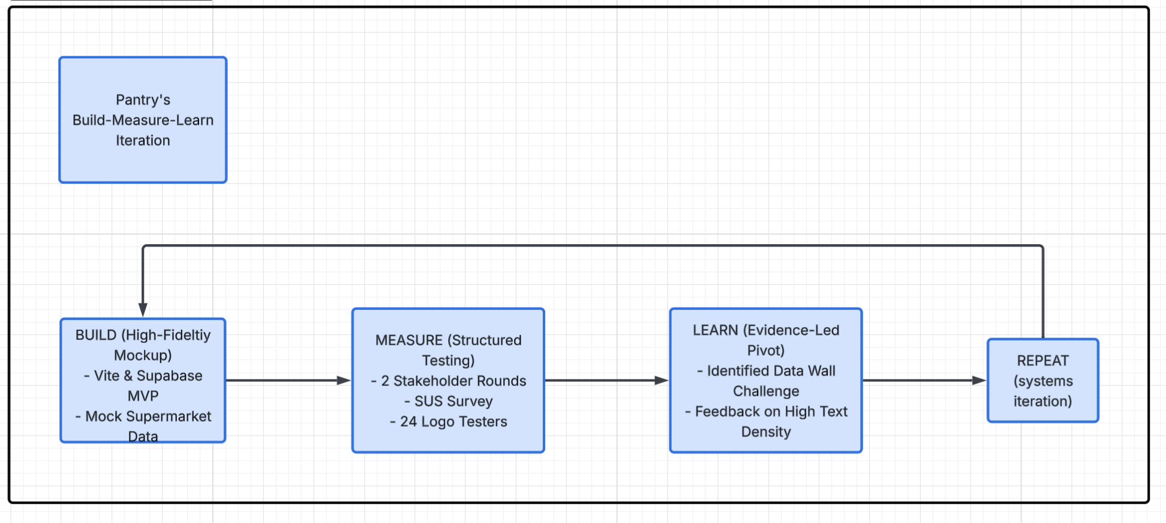
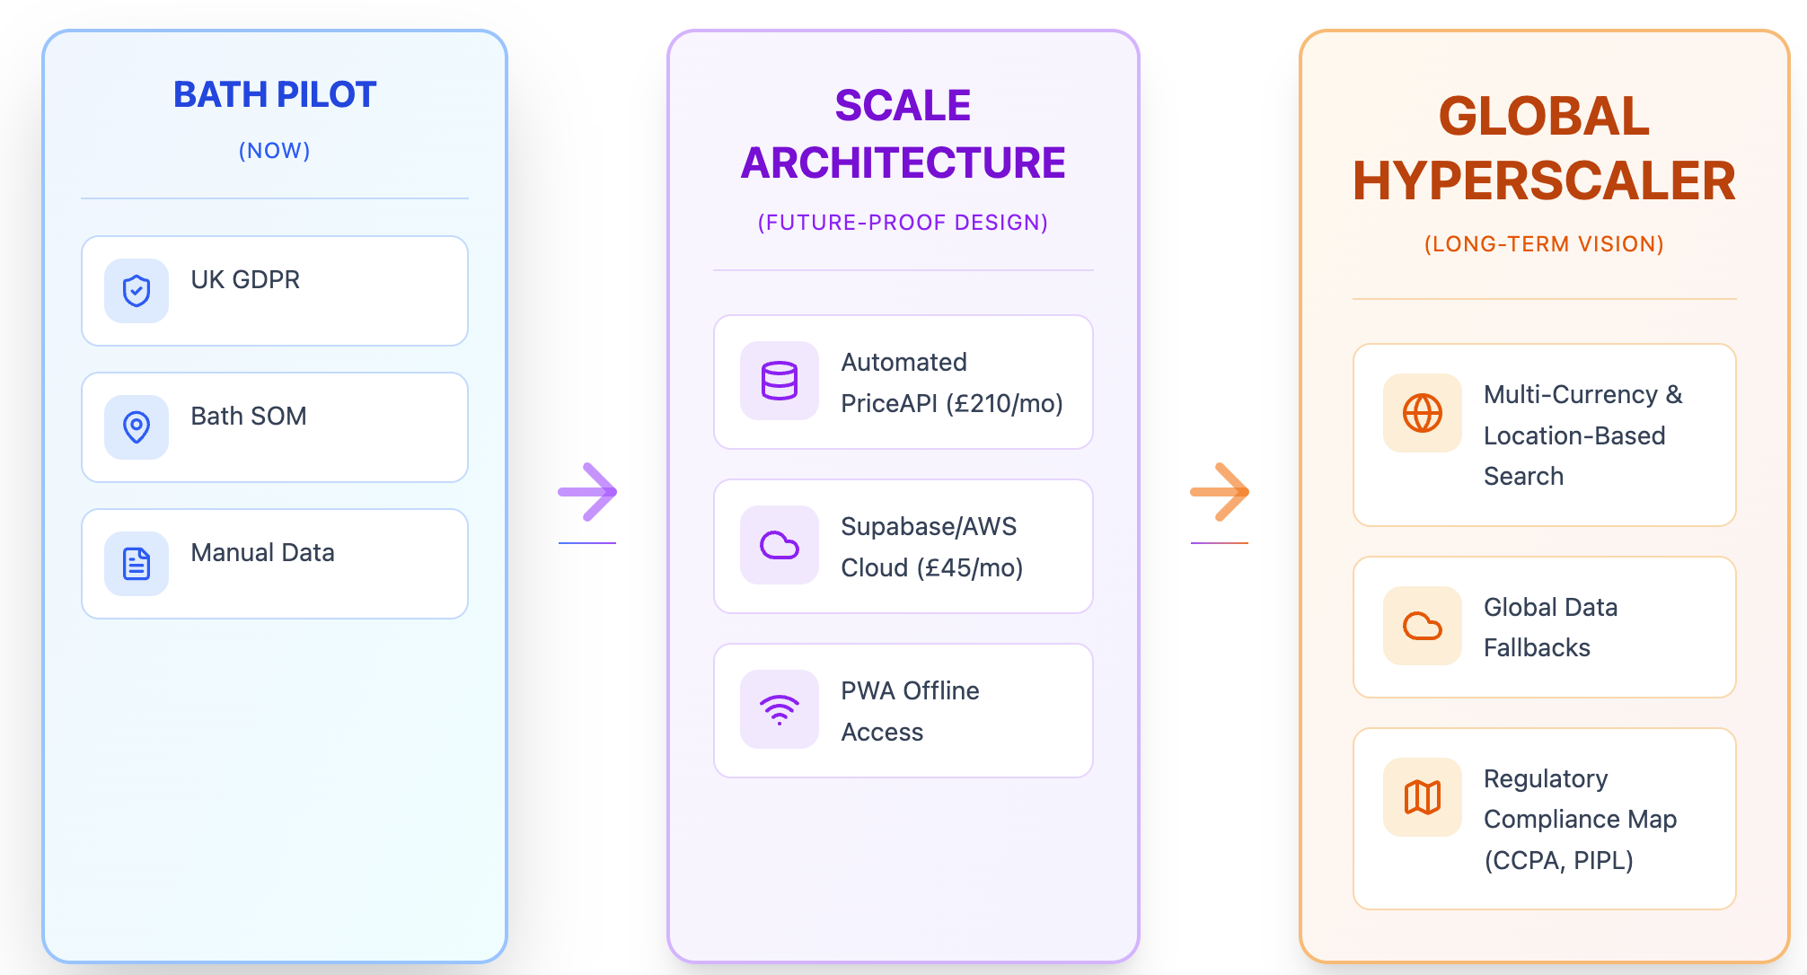

Possible Questions
1. "You mentioned a 'Data Wall' with major supermarkets. If they won't give you API access, how do you move beyond mock data to a live product?"
- Answer: "Our strategy is two-fold. First, we are targeting smaller, independent retailers as a referral engine. They gain more from our traffic than the 'Big Four.' Second, we've built the system to integrate open-source databases like Open Food Facts as a fallback [Presentation Script]. This allows us to provide value while we use our growing user base as leverage for official partnerships."
2. "How do you ensure 'Loyalty Transparency' remains accurate if supermarkets change their pricing structures frequently?"
- Answer: "Our 'Loyalty Toggle' is designed to be a transparent mapping tool. While we currently use mock data to validate the UI , our future live backend will utilize real-time price parsing that distinguishes between 'Member' and 'Non-member' unit prices, specifically to comply with the DMCCA 2024 regarding pricing transparency."
3. "The Recipe-to-Basket feature is currently a mockup. What is the technical hurdle to making it live?"
- Answer: "The hurdle isn't the AI—it's the data integrity of the mapping. We've already validated the user demand for this feature through our 87% SUS score and stakeholder interviews. Our next step is moving the parsing logic from a mockup to a live backend using Vite and Supabase once we've finalized our data sourcing strategy."
4. "How does the 'Smart Sort' feature work in practice?"
- Answer: "Smart Sort is a custom logic we developed to balance price savings against travel distance [Presentation Script]. It prevents the app from suggesting a store that saves you £1 but costs you £5 in fuel or an hour of travel, ensuring the 'cheapest' option is also the most practical one."
5. "Your CAC (Customer Acquisition Cost) target is under £2. Isn't that overly optimistic for a crowded app market?"
- Answer: "Actually, it's based on our Micro-influencer loop strategy. By targeting specific student communities (like the 2,500 students in our Bath SOM pilot) and using authentic word-of-mouth rather than broad paid ads, we can keep costs low. Our current waitlist success on GitHub Pages already proves we can capture leads at a low cost."
6. "How do you plan to monetize a 'free-to-use' model while covering a £430/month burn rate?"
- Answer: "Our primary revenue model is Affiliate/Referral fees. We only need 359 shops per month to break even, which represents just 15% of our Bath target market. As we scale, the high LTV (Lifetime Value) projection of £29.76 provides a healthy 15:1 ratio against our acquisition costs."
7. "You mention CO2e tracking. How do you quantify 'emissions avoided' through shopping?"
- Answer: "This is a future integration. We plan to map the carbon footprint of products using eco-friendly indicators. By using our Inventory Awareness feature to prevent over-purchasing and surplus, we can quantify the waste—and therefore the emissions—the user has avoided."

"Why did you choose the Vite, Supabase, and Expo stack for your MVP?"
- Answer: This stack was chosen for speed and cross-platform compatibility. Vite provides a fast frontend development experience, Supabase offers a scalable backend-as-a-service with built-in security, and Expo allowed us to deploy the interactive version directly to mobile devices for immediate user feedback.
"How does your 'Inventory Awareness' feature work without being a burden to the user?"
- Answer: The goal is to prevent over-purchasing by reminding users of existing pantry stock. We aim to use the Recipe-to-List parser to cross-reference what the user already has, ensuring they only buy the precise quantities needed to eliminate household surplus.
"You mention using AI for grammar checks only; how do you plan to implement the Recipe-to-Basket AI safely later?"
- Answer: We prioritize AI Explainability. The algorithm will provide transparent mapping so users can verify ingredient conversions, which is vital for those with strict religious or health-related dietary needs.
"Your System Usability Scale (SUS) score was 87%. What was the single biggest change that led to that high score?"
- Answer: Moving from our initial prototype to the MVP involved a significant "simplification" phase. We addressed "high text density" and "complex navigation" by removing low-value features and strengthening visual cues.
"Who is your 'Student SOM' and why start with the University of Bath?"
- Answer: Our Serviceable Obtainable Market (SOM) is 2,500 students. We chose Bath for the pilot because we have already gathered direct feedback from these students to validate demand and collected real email sign-ups via our live waitlist
"What happens after your 7-month runway ends if you haven't secured a partnership?"
- Answer: Our £430 monthly burn rate is intentionally lean. Because we have a 15:1 LTV-to-CAC ratio, we can remain sustainable through affiliate revenue even at a small scale—needing only 359 shops per month to break even.
"How do 'Viral Loops' help you reach your target CAC of under £2?"
- Answer: We leverage micro-influencer partnerships and community challenges. By creating shareable content around "grocery savings challenges," we trigger word-of-mouth growth within the student community, keeping acquisition costs significantly lower than traditional paid ads.
"How does your 'Guest Mode' actually work while still providing price comparisons?"
- Answer: This is part of our Privacy-First ethics. Users can compare prices and stores without the app tracking their personal shopping habits or requiring a full profile, fulfilling our "Privacy-by-Design" commitment.
"How will you handle data compliance if you expand to the US or China?"
- Answer: Our scale architecture is already "future-proof". We have mapped out regulatory requirements for the CCPA (USA) and PIPL (China) to ensure our framework remains compliant as we move toward a global hyperscaler model.

